**OOAD Assignment 01**

**Original Classes:**

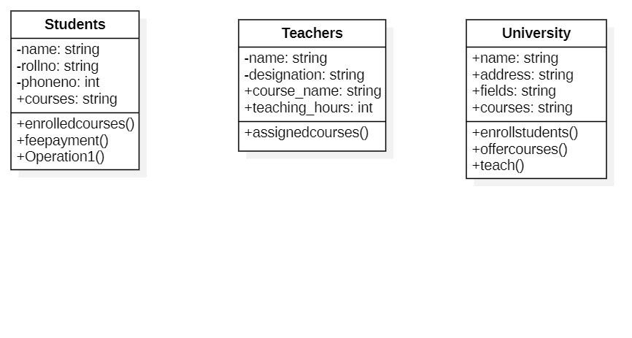

**Classes with relations assigned:**

